13.3.3 Editors - Video Sequence Editor - Sidebar - Sequencer - Strip tab
Detailed table of content 2
Strip Tab 5
Strip tab header 5
Compositing Panel 5
Transform Panel 5
Position X 5
Y 5
Rotation 6
Mirror 6
Video Panel 6
Color Panel 6
Saturation 6
Multiply 6
Convert to Float 6
Time Panel 6
Lock 6
Channel 7
Start 7
Duration 7
End 7
Scene Panel 7
Scene Property 7
Input 7
Mask Panel 8
Mask Property 8
Effect Strip Panel 9
Effect strip type Color Mix 9
Effect strip type Text 9
Effect strip type Gaussian Blur 11
Effect strip type Multicam 11
Effect strip type Speed 11
Effect strip type Color 12
Effect strip type Transform 12
Effect strip type Glow 13
Effect strip type Wipe 14
Effect strip type Alpha over Drop 14
Effect strip type Multiply 15
Effect strip type Gamma Cross 15
Effect strip type Alpha Under 15
Effect strip type Alpha Over 16
Effect strip type Subtract 16
Effect strip type Add 16
Effect strip type Crossfade 17
Custom Properties Panel 17
Add 17
Edit 17
Remove 17

Detailed table of content
Detailed table of content
Detailed table of content 2
Strip Tab 5
Strip tab header 5
Compositing Panel 5
Blend 5
Opacity 5
Transform Panel 5
Position X 5
Y 5
Rotation 6
Mirror 6
Video Panel 6
Strobe 6
Reverse Frames 6
Color Panel 6
Saturation 6
Multiply 6
Convert to Float 6
Time Panel 6
Lock 6
Channel 7
Start 7
Duration 7
End 7
Current Frame 7
Scene Panel 7
Scene Property 7
Scene Browser 7
Scene edit box 7
Remove 7
Input 7
Camera settings 8
Volume 8
Camera 8
Show Grease Pencil 8
Transparent 8
Mask Panel 8
Mask Property 8
Mask Browser 8
Mask edit box 8
Fake User 8
Remove 8
Effect Strip Panel 9
Effect strip type Color Mix 9
Input 1 9
Input 2 9
Swap Strips 9
Blend Mode 9
Blend Factor 9
Effect strip type Text 9
Text 9
Wrap Width 9
Style sub panel 9
Font property 10
Font browser 10
Open 10
Font Edit Box 10
Fake User 10
Open Font 10
Remove 10
Size 10
Color 10
Shadow 10
Shadow color 10
Box 10
Box Color 10
Box Margin 10
Layout sub panel 11
Location X/Y 11
Anchor X/Y 11
Effect strip type Gaussian Blur 11
Input 1 11
Size X 11
Y 11
Effect strip type Multicam 11
Source Channel 11
Cut to 11
Effect strip type Speed 11
Input 1 11
Stretch to Input Strip Length 11
Use as Speed 12
Speed Factor 12
Frame Number 12
Scale to Length 12
Multiply Speed 12
Frame Interpolation 12
Effect strip type Color 12
Color Picker 12
Effect strip type Transform 12
Input 1 12
Interpolation 12
Translation Unit 13
Position X 13
Y 13
Uniform scale 13
Scale X 13
Y 13
Rotation 13
Effect strip type Glow 13
Input 1 13
Threshold 13
Clamp 13
Boost Factor 13
Blur Distance 13
Quality 13
Only Boost 14
Effect strip type Wipe 14
Input 1 14
Input 2 14
Swap Inputs 14
Transition type 14
Direction 14
Blur width 14
Angle 14
Default Fade 14
Effect strip type Alpha over Drop 14
Input 1 14
Input 2 14
Swap Inputs 14
Default Fade 15
Effect strip type Multiply 15
Input 1 15
Input 2 15
Swap Inputs 15
Effect strip type Gamma Cross 15
Input 1 15
Input 2 15
Swap Inputs 15
Default Fade 15
Effect strip type Alpha Under 15
Input 1 15
Input 2 15
Swap Inputs 15
Default Fade 16
Effect strip type Alpha Over 16
Input 1 16
Input 2 16
Swap Inputs 16
Default Fade 16
Effect strip type Subtract 16
Input 1 16
Input 2 16
Swap Inputs 16
Effect strip type Add 16
Input 1 16
Input 2 16
Swap Inputs 16
Effect strip type Crossfade 17
Input 1 17
Input 2 17
Swap Inputs 17
Default Fade 17
Custom Properties Panel 17
Add 17
Edit 17
Remove 17

Strip Tab

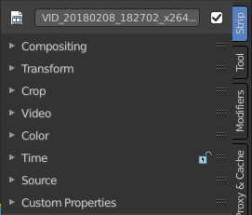
The strip tab contains all the strip type related settings. For the different strip types see the Add menu.

Some panels have the same content for all strip types. Some not. Some strip types have their own panels.

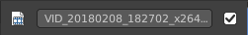
Strip tab header
In the strip tab header you will see an icon for the current strip type. The name of the strip. And a checkbox to set this strip active.
The strip can be renamed by double clicking left into the edit box.

Compositing Panel
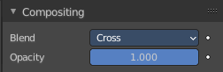

Blend
The blend method to control how the strip combines with other strips.

Opacity
How much the strip color affects other strips.

Transform Panel
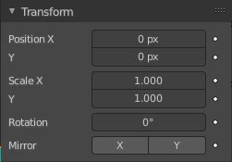

Position X
The X offset.

Y
The Y offset.

Rotation
The rotation around the image center.

Mirror
Flip on the X and/or Y axis.

Video Panel

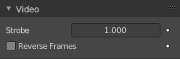
Strobe
Don't display every frame, but just every nth frame.

Reverse Frames
Reverse the frame order.

Color Panel
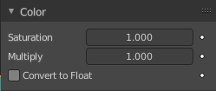

Saturation
The intensity of the input color.

Multiply
Multiply colors by this factor.

Convert to Float
Convert input to float data.

Time Panel

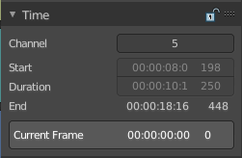
Time related settings.

Lock
Lock strip so that it cannot be transformed.

Channel
The channel of the strip.

Start
The start frame of the strip.

Duration
The duration of the strip.

End
The end frame of the strip.

Current Frame
Info box that displays the position of the frame cursor.

Scene Panel

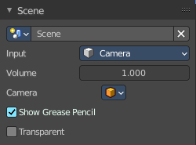
This panel just shows with strip type scene.

Scene Property

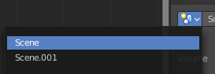
Scene Browser
A scene browser that contains the available scenes in the file.

Scene edit box
The name of the scene. It can be renamed by double clicking into the edit box.

Remove
Remove the scene as the active one. Note that the scene is still available in the scene browser.

Input
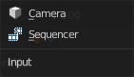
Type of input to use. The camera of the scene. Or a file from the sequencer in this scene.

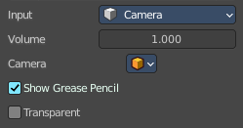
Camera settings

Volume
The audio volume.

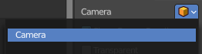
Camera
Which camera of the scene to use.

Show Grease Pencil
Show grease pencil strokes in OpenGL previews.

Transparent
Use a transparent background.

Mask Panel

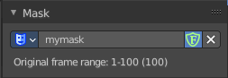
This panel just shows with strip type Mask.

Mask Property

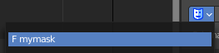
Mask Browser
A mask browser that contains the available masks in the file.

Mask edit box
The name of the scene. It can be renamed by double clicking into the edit box.

Fake User
Assign a fake user to this mask. Fake users is a odd concept to keep data in the scene even if it has no user somewhere. The fake user is then a dummy user so that the object is not deleted when saving the scene.

Remove
Remove the scene as the active one. Note that the scene is still available in the scene browser.

Effect Strip Panel
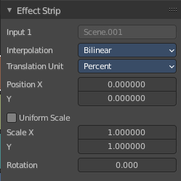
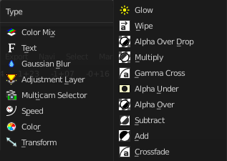
Settings for the single effect strip types.

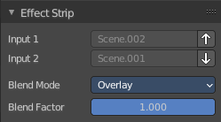
Effect strip type Color Mix

Input 1
The first strip.

Input 2
The second strip.

Swap Strips
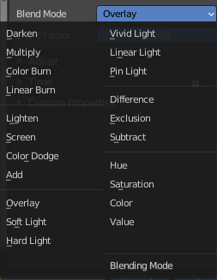
Swap the strips.

Blend Mode
The color blend mode to use.

Blend Factor
The blend factor. 1.000 means 100%.

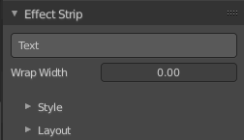
Effect strip type Text

Text
The text to displayed.

Wrap Width
World wrap width as factor. Zero disables the wrap.

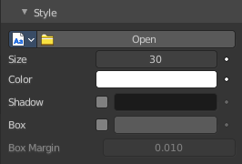
Style sub panel

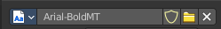
Font property
When no font is loaded then the internal font is used.

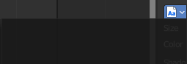
Font browser
The list of loaded fonts. This list is empty by default.

Open
Load a font.

Font Edit Box
Display the current active font. You can rename the font by double clicking in the edit box.

Fake User
Assign a fake user to this font. Fake users is an odd concept to keep data in the scene even if it has no user somewhere. The fake user is then a dummy user so that the object is not deleted when saving the scene.

Open Font
Load a font.

Remove
Remove the selected font as the active one. Note that the font is still in the list then.

Size
Size of the text.

Color
The text color.

Shadow
Creates a shadow of the specified color under the text.

Shadow color
The color of the shadow. Clicking at the color field opens a color dialog.

Box
Display colored box behind text.

Box Color
The color of the box

Box Margin
The margin of the box. Based at the image width.

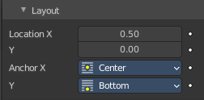
Layout sub panel

Location X/Y
Positions the text on the X, Y axis.

Anchor X/Y
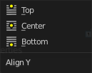
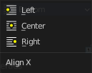
Horizontal (X) or vertical (Y) anchor point of the text relative to the location.

Effect strip type Gaussian Blur

Input 1
The strip to blur. This strip cannot be changed. You need to apply the effect with the correct strip selected.

Size X
The size of the blur along X axis.

Y
The size of the blur along Y axis.

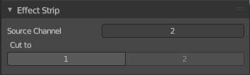
Effect strip type Multicam

Source Channel
The channel which the Multicam Selector gets its input from.

Cut to
Cuts the Multicam strip at the current frame and changes the Source Channel automatically to the selected channels.

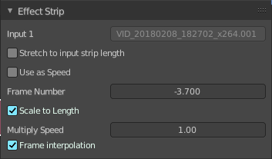
Effect strip type Speed

Input 1
The strip to blur. This strip cannot be changed. You need to apply the effect with the correct strip selected.

Stretch to Input Strip Length
Automatically calculates the Speed Factor based on the length of the input strip. So if you make a strip 1/2 the original size the sequence will play back at 2 times the speed.

Use as Speed
Calculates the scale value based on a Speed Factor.
Note! You will have to manually re-adjust the length of the strip accordingly.

Speed Factor
Multiplies the current speed of the sequence by this value. So, a value of 0.5 will make the sequence half as fast while 2 would make the sequence twice as fast.

Frame Number
Specifies a frame to remap the current frame to, for example, setting this value to 50 displays the 50th frame. This can then be manually key framed to recreate the animation.

Scale to Length
Maps the frame range on a 0-1 scale. For example, using this and a Frame Number of 0.5 will select the frame halfway through the sequence.

Multiply Speed
A multiplier applied after all other calculations.

Frame Interpolation
Cross fades between frames to reduce screen tearing when the speed is slower than the original frame rate.

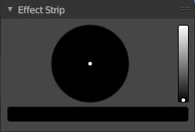
Effect strip type Color

Color Picker
Adjust the color of the color strip.

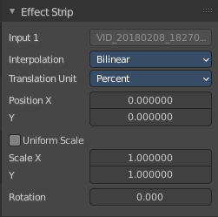
Effect strip type Transform

Input 1
The strip to transform. This strip cannot be changed. You need to apply the effect with the correct strip selected.

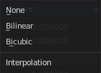
Interpolation
The interpolation type for the transform.

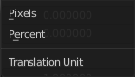
Translation Unit
The measure unit to use for the transform.

Position X
Amount to move the input in the X axis.

Y
Amount to move the input in the Y axis.

Uniform scale
Scale uniformly, preserve the aspect ratio.

Scale X
Amount to scale the input in the X axis.

Y
Amount to scale the input in the Y axis.

Rotation
Degrees to rotate the input.

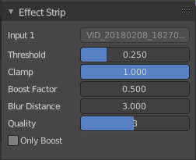
Effect strip type Glow

Input 1
The strip to use. This strip cannot be changed. You need to apply the effect with the correct strip selected.

Threshold
Minimum intensity to trigger a glow.

Clamp
The brightness limit of intensity.

Boost Factor
Brightness multiplier.

Blur Distance
The radius of the glow effect.

Quality
The accuracy of the blur effect.

Only Boost
Show the glow buffer only.

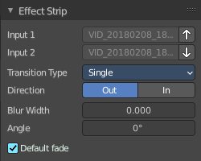
Effect strip type Wipe

Input 1
The first strip.

Input 2
The second strip.

Swap Inputs
Swap the two strips.

Transition type
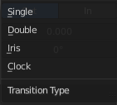
The wipe effect type.

Direction
The direction of the wipe.

Blur width
The width of the blur edge, relative to the image size.

Angle
The edge angle.

Default Fade
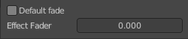
Use the builtin default effect time, which is as long as the fade clip. Or adjust the effect time.

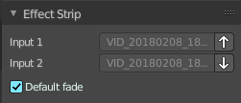
Effect strip type Alpha over Drop

Input 1
The first strip.

Input 2
The second strip.

Swap Inputs
Swap the two strips.

Default Fade
Use the builtin default effect time, which is as long as the fade clip. Or adjust the effect time.

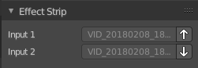
Effect strip type Multiply

Input 1
The first strip.

Input 2
The second strip.

Swap Inputs
Swap the two strips.

Effect strip type Gamma Cross

Input 1
The first strip.

Input 2
The second strip.

Swap Inputs
Swap the two strips.

Default Fade
Use the builtin default effect time, which is as long as the fade clip. Or adjust the effect time.

Effect strip type Alpha Under

Input 1
The first strip.

Input 2
The second strip.

Swap Inputs
Swap the two strips.

Default Fade
Use the builtin default effect time, which is as long as the fade clip. Or adjust the effect time.

Effect strip type Alpha Over

Input 1
The first strip.

Input 2
The second strip.

Swap Inputs
Swap the two strips.

Default Fade
Use the builtin default effect time, which is as long as the fade clip. Or adjust the effect time.

Effect strip type Subtract

Input 1
The first strip.

Input 2
The second strip.

Swap Inputs
Swap the two strips.

Effect strip type Add

Input 1
The first strip.

Input 2
The second strip.

Swap Inputs
Swap the two strips.

Effect strip type Crossfade

Input 1
The first strip.

Input 2
The second strip.

Swap Inputs
Swap the two strips.

Default Fade
Use the builtin default effect time, which is as long as the fade clip. Or adjust the effect time.

Custom Properties Panel


Here you can define custom properties that can be used for scripting.

Here you might also find custom properties from addons or scripts.

Add
Adds a new property.


Edit
Opens a panel where you can adjust the settings for the custom property.

Remove
Removes the property.

